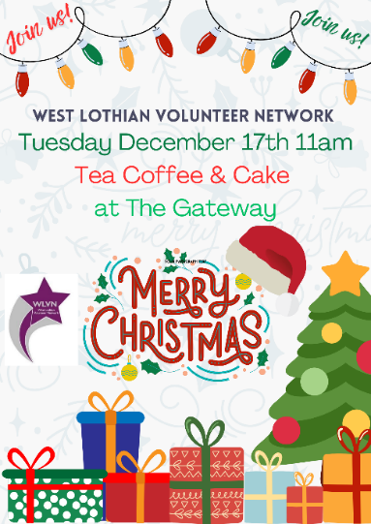**West Lothian Volunteer Network**

Tuesday December 17th 11am

**Chair:** Linden Raeburn (West Lothian Council) Linden.Raeburn@westlothian.gov.uk

**Note Taker:** Victoria Isbister (VSGWL) [Victoria.Isbister@VSGWL.org](mailto:Victoria.Isbister@VSGWL.org)

**Attended:** Claire Garten (NHS), Jennifer Harley (Team Jak), Johnny Imrie (Active Schools), Lisa Callaghan (Home Start), HCL, Ainsleigh (WLC)

**Apologies:** Dorothy Terhune (NCT), Martin Thomson (Business Gateway), Gillian Dunnigan (Social Security),

1. Welcome and Apologies

Linden opened the last meeting of the year and thanked everyone for coming.

1. Last minutes and previous actions

* Linden advised they had a stall outside Asda in Livingston for Challenge poverty week, but this was poorly attended.
* Possible guest speakers: Adele Bayne – voice ability, advocacy service, unsure if have volunteers but could be of interest? [adele.chalmers@voiceability.org](mailto:adele.chalmers@voiceability.org) (Victoria will email invite)
* Dancing with Dementia – poster in chemist – Claire will find out contact info.

1. Volunteer Fayre: January 2025

* Please see poster and advertise in January
* WLC will advertise outside building using big banner
* Tea and Coffee available. Café for food onsite.
* Never done in January before so see how busy it is.
* 12 people registered so far – please email Victoria if interested
* Set up from 12.30 at Bathgate partnership Centre.

1. Service Updates

HCL – Looking to promote services in Blackridge / Armadale (see poster). Geographic remoteness. General discussion surrounding services and costs, specifically hospital transport. HCL is accessible service, similar to patient transport, door to door service - there is a charge but also additional support (driver can enter destination with person to ensure they are ok if needed). HCL also operates in Edinburgh so can take people from Edinburgh to St Johns – this is useful as some services has just moved. Only Org who work across the whole of Lothian. Do struggle to get volunteer drivers, recruit a lot. Discussion surrounding insurance– seems to be getting harder (& more expensive). Issues across the board. HCL 35 vehicles. [HCL Transport](https://www.hcltransport.org.uk/).

Active Schools – WL community sport team. Been recruiting volunteers from high schools, now realising there’s a scope for older demographic. Linden offered to link in as they have corporate approach volunteering at WLC – if anyone would like any support volunteering please get in touch.

Home Start – 5 or 6 volunteers starting Jan 13th. Run 3 courses per year. For families who have 1 child under 5. Helps reduce isolation by getting out and about in community, assist to appointments and help with kids. Professional level friendship. Hoping to start new family group in Bathgate Mid-March, currently run Blackburn and Livi, aware that quite a lot of families in the area struggle to get to either Blackburn or Livi. 33% increase in families looking for support however volunteer numbers reducing, constantly trying to recruit volunteers.

NHS Lothian – volunteering on pause. Revamping processes and opportunities in the new year, hoping to include ad hoc opportunities. Few roles outside office in St Johns including Therapet support volunteers who would support before and after visit. Claire is currently managing 115 volunteers across 4 sites. 80% are under 18 looking to go into medicine. Build a lovely link with conservation volunteers on site and held party last Wednesday with food and drink, made own wreaths.

Team Jak – Supporting around 500 families across Scotland, 50 volunteers and permanent staff. Lots of evets including Christmas fair, party and carol concert. It is the 10th anniversary of Jack’s death. Music director has helped craft song, and the children have written 2nd verse.

WLC – not recruiting currently due to budget issues. Around 42 currently. Christmas party last week.

1. Volunteer stories and celebrations

* 2 volunteers – Stuart and Ed - from NHS Lothian won Voluntary Service award in NHS Lothian Celebrating Success. [Celebrating Success | Finalists – News & Media](https://news.nhslothian.scot/celebrating-success-finalists/)
* 2nd book published TJ and the bee [TJ and the Bee Book — Team Jak](https://www.teamjak.org.uk/shop/tj-and-the-bee-book).
* “Have Hope and Be Happy”: Jak’s Singing Denners: <https://fb.watch/wBwQTYztyg/>

1. Volunteer Event

* No update on budget for event.
* Can access College for free so Plan B could be tea and coffee there in June.
* Would need to obtain donations for tea, coffee, biscuits etc
* Discussion surrounding lack of funding and impact on volunteers. Cost of living impact – some retired people now having to work part time, so don’t have the time to volunteer.
* Linden spoke about goodwill referring to recent annual campaign for donated toiletries which in the past has been enough to make up 200 bags – this year was 100 bags.

1. Group photo for website and social media See VSGWL and WLVN Facebook 😊
2. AOCB - None
3. Next meeting date: Tuesday January 28th 2pm (Online)

Actions

1. Guest Speaker list 2025 – Victoria
2. Project 2025 meeting dates – Victoria – last Tuesday of the month 2pm online (completed)
3. Volunteer Mapping – January agenda
4. Contact Asda community champion
5. VSGWL Volunteer vacancies: <https://salesforce.123formbuilder.com/form-6733157/volunteer-opportunity-form-new>
6. Volunteer Fayre – please email Victoria if you wish to book a stall.
7. Share events on WLVN Facebook or email Victora, Anne H or Linden