West Lothian Volunteer Network
Tuesday November 12th 2pm

Chair: Linden Raeburn (West Lothian Council) Linden.Raeburn@westlothian.gov.uk
Note Taker: Victoria Isbister (VSGWL) Victoria.Isbister@VSGWL.org

Present: Jennifer Harley (Team Jak), Ray Fallan (VSGWL), Elizabeth Campbell (HCL Transport), Martin Thomson (Business Gateway), Susan Proudfoot, Leighann Bishop (Xcite), Claire Garton (NHS), Jocelyn Lockhart (WLCAN), Lisa Callaghan (Home Start), Glenn Marsters (Active Schools)
Apologies: Jacqui Marwick (Cruse), Dorothy Terhune (NCT), Gillian Dunnigan (Social Security), Carol (WLFIN), Maureen Colquhoun (WLC), Ainsleigh(WLC)

- Welcome and Apologies
Linden opened the meeting and everyone introduced themselves.

- Last minutes and previous actions
- How many volunteers are there in WL? – How can we map this – Linden did a survey but hasn’t been able to check for any recent responses. Ever changing number. Look in new year to see how better we can do this. **January
- Contact Carol if any corporate volunteering opportunities (plenty of time needed to plan ahead): carol.tugman@socialsecurity.gov.scot
- Contact Asda community champion – alorrai.s04176.uk@wal-mart.com: Abi Lorraine: Community Life Champion: Asda Livingston: Tel: 01506835980 ext 222 – who was doing this?

- Guest Speaker: None arranged

- Volunteer celebration event 2025
As everyone knows, the Council is in a difficult financial position and the money set aside may be withdrawn as non-essential spending. However, Nahid is still supportive. Waiting to hear. Linden suggested suspending planning. What has been done before was well received, so a lot of money would not necessarily be needed.

- Volunteer Fayre: Monday January 20th 2025
12.30 – 3.30pm: Hall in Bathgate Partnership Centre. Linden will create poster. Accommodate as many people as possible. Previously did it in the ‘lobby’ and feedback was that this was difficult as thoroughfare.
- Volunteer Successes
- Swathed in Scarlet Chiffon published by Seahorse Publications £465 made for Team Jak poems by Jenifer Harley. Seahorse Publications — Swathed in Scarlet Chiffon
- Ray shared event held at The Gateway where she helped groups such as Scouts & Schools use Saltire awards to celebrate their volunteers.

- Social Media Page
Reminder to all members, if they want anything shared, Ann Holloway social media volunteer, running WLVN account.

- Service Updates
- WLC: Currently 45 volunteers – had flurry of new applications, mainly through pathways processes. Next programmes December (struggling to find placements, 2 weeks prior to Christmas) and February. Always looking for placements. Couple days in classroom e.g. confidentiality, confidence building then placements for couple weeks in office environment. Networking at Howden Park supporting people affected by cancer, brought together services and was well attended, so plan to hold annually.
- NHS Lothian: Closed online applications yesterday, may open again Jan/Feb time. 20% increase applicants and lost 2 staff so have reduced capacity to support volunteers. Claire currently manages 115 volunteers over 4 sites - 25 are still to be placed and 45 still be trained. 600 total over all NHS Lothian sites. Still has some roles trying to recruit for so please contact Claire who is always happy to have a chat. There has been an increase in 16–18-year-old applicants and people from abroad. Volunteers will be are in over Christmas and New Year.
- Xcite: Silver Sunday from November 17th, mostly for people who live alone. Awards tomorrow in Manchester to support Eileen who has been short listed. Longest standing volunteer at 17 years.
- Team Jak: "49 adults and children – from our Angel Families, parents and siblings of children who lost their lives to cancer went for a weekend of relaxation/yoga with pamper gifts and time to share together at the Hilton by Double-tree Cumbernauld. We also had our annual Halloween Party for children and adults. The den has been closed to families for 2 weeks to freshen it up. Thanks to Donny’s carpets who fitted carpet in our Family zone and Gerald Smith, Painter and Decorator from Whitburn who painted the Family Zone and Studio job as his gift to us. Martin and his team at Scottish Gas, corporate volunteers, also gave their time to help tidy up the Den by volunteering. The Board have also held their Strategy, planning meeting and AGM. Date of Christmas Fayre is 24 November"
- “I was on the Board of Craigsfarm when it was going through the asset transfer from West Lothian - lots of work involved in that process but we got there with the help of consultants. Not involved any more though - it is doing well. In my Team Jak update I forgot to mention we have volunteers from local high schools, James Young, St Margarets and Deans High School who have been helping out on Friday afternoons. Wouldn't like to miss them out.”
- Business Gateway: Attending meeting to network - to see how people operating / how he can possibly help. Martin spoke about some of the work he is involved in just now including Food Network, Community Centres – wide scale consultation going on.
- Home start: 23 volunteers training. Busy. May be able to offer pathway opportunities in January inc a receptionist on a Saturday morning. Linden reflected that there are an increasing number of people who are interested in admin / office tasks, acknowledging that experience is needed for these vacancies. “Continuing to recruit for volunteers to support families in their homes. This would be for a couple of hours a week for 9 months or longer. If you know anyone over 21 who would be interested in giving some time and lending a listening ear to a family please get in touch with us on admin@homestartwl.org.uk. Many of our families would like someone to go with them to the shops, a toddler group, help them get to appointments or go to a local park. All expenses are paid and lots of training opportunities are given also.
- HCL: Had full bus from WL to Edinburgh for AGM by volunteer driver. Nice to meet lots of people. Attending Carers rights later this month.
- Active Schools: Big shift over from using pool of paid coaches to volunteer workforce, keen to be involved in fair in January. Held event earlier this year at WL college which mainly focused on young volunteers within high school, S3-S6. Support teams and festivals.
- VSGWL: No further meeting or update about Volunteer Friendly. Ray attends DWP Livingston once a month. Found that some people not ready for volunteering so did presentation to DWP coaches which was welcomed and she is now seeing different people coming forward.
- Reminder to send any volunteer opportunities to: https://salesforce.123formbuilder.com/form-6733157/volunteer-opportunity-form-new. Wendy Swan VSGWL runs assisted volunteer programme.
- Linden followed that Pathways programme might be helpful here
- School Bank: “We've had lots of corporate volunteers in this last couple of months who have been amazing! Currently full for corporate vols until the new year. Going to get in touch with Carol from Social Security as she mentioned they needed lots of time to organise. Got 3 new volunteers in the pipeline to start so hopefully they be started soon. We only have regular vols in twice a week due to limited time/space (currently Tues AM and Thurs PM) and corporate vols on select Fridays throughout the year. We've also just taken on about 6 new washing volunteers recently on the back of a social media drive! We have 2 ladies from the Trust Project coming in on a Tuesday for an hour and hoping to have a few S6 pupils from Pinewood coming in to volunteer for an hour on a Tuesday also, through Enable. Just awaiting confirmation of this
Freshening up second-hand clothing.”

- Next meeting date:
11am Tuesday Dec 17th in person at the Gateway with a Christmas refreshment! Everyone welcome (online link available)

Actions
- Volunteer Fayre poster – Linden
- All share on social media – All members
- Guest Speaker list 2025 – Victoria
- Project 2025 meeting dates – Victoria & Linden
- Volunteer Mapping – January agenda
- Contact Asda community champion
- VSGWL Volunteer https://salesforce.123formbuilder.com/form-6733157/volunteer-opportunity-form-new
- Volunteer Fayre – please email Victoria if you wish to book a stall.


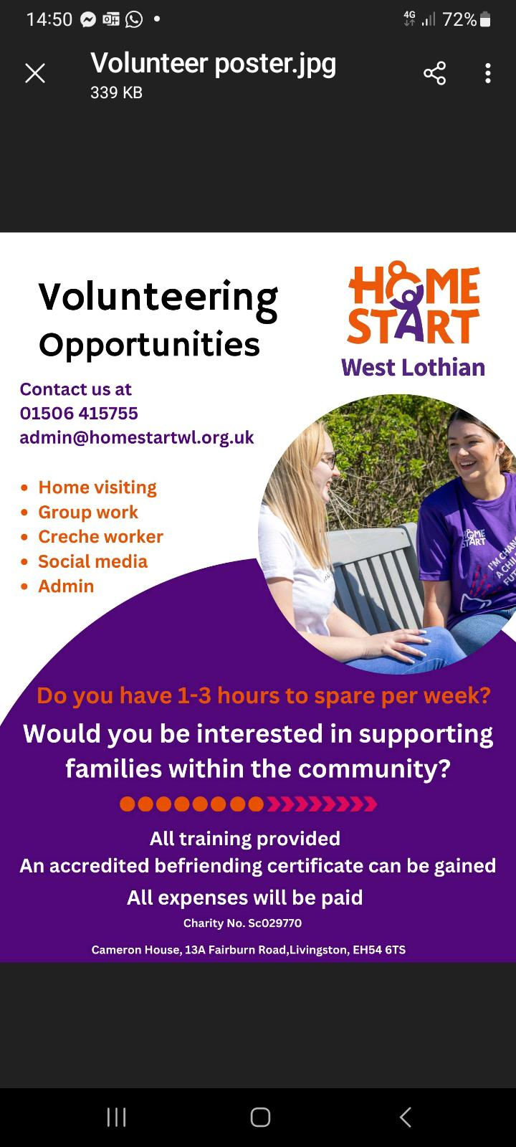



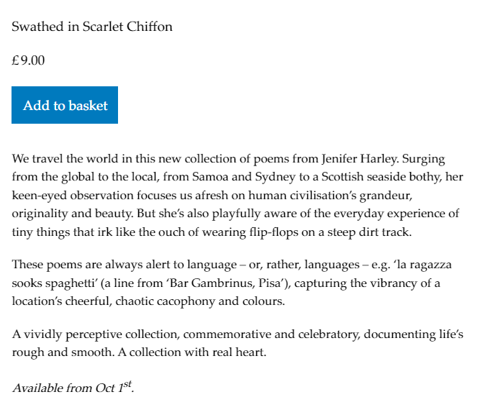

Event Subgroup – suspended for now
(Aug update)
Location: WLC College Livi – cheapest, fits with aims (student practice)
Could hire function room (which comes with function room)
Hillcroft (less than £500 – see appendix) (poor bus issue?)
Stadium – Simon food creations
Strathbrock – Xcite, community centre, holds 200
Bathgate Golf Club
Transport: Ideally on Bus route (issue region wide)
Date: Ideally volunteers week, may have to fit in with college, First week in June
Time: Afternoon into Evening, 5pm - 9pm or Afternoon (what would volunteers prefer)
Dress code: Posh and fancy but not incurring additional costs, want to look after people and make them feel good. Need to do what people want.
Decorations:
Refreshments: Sit down meal (100 people exc staff). Food is part of celebration.
The Larder donating to Xcite event. Buffet? BBQ.
Catering: College students
Number of people: 5 places per org
Budget: - £10,000. One big event or 2 or 3 events?
Entertainment: Disco, live band expensive. College music. Needs to be something to suit everyone. Disco might put people off. Regal music group. Background music. Choir. Combination of music /games.
Alcohol: Would need license or buy someone in or hide a venue.

In the past
Certificates presented to Orgs and afternoon tea. Numbers restricted to 100 post covid.
Before that there was entertainment with coffee and snacks, 250 people.

Actions
- Ray will ask her Nephew for costings about alcohol van
- Survey own volunteers (Xcite, WLC and School Bank) on issues such as event timing

